DAY-5
1. implement Queue (its operations) using Arrays.
#include <stdio.h>
#define MAX_SIZE 5
typedef struct {
int data[MAX_SIZE];
int front;
int rear;
int size;
} Queue;
void initQueue(Queue* q) {
q->front = 0;
q->rear = 0;
q->size = 0;
}
int isEmpty(Queue* q) {
return q->size == 0;
}
int isFull(Queue* q) {
return q->size == MAX_SIZE;
}
void enqueue(Queue* q, int element) {
if (isFull(q)) {
printf("Queue is full. Cannot enqueue %d.\n", element);
return;
}
q->data[q->rear] = element;
q->rear = (q->rear + 1) % MAX_SIZE;
q->size++;
}
int dequeue(Queue* q) {
if (isEmpty(q)) {
printf("Queue is empty. Cannot dequeue.\n");
return -1;
}
int element = q->data[q->front];
q->front = (q->front + 1) % MAX_SIZE;
q->size--;
return element;
}
int peek(Queue* q) {
if (isEmpty(q)) {
printf("Queue is empty. Cannot peek.\n");
return -1;
}
return q->data[q->front];
}
int size(Queue* q) {
return q->size;
}
void printQueue(Queue* q) {
printf("Queue: ");
for (int i = 0; i < q->size; i++) {
printf("%d ", q->data[(q->front + i) % MAX_SIZE]);
}
printf("\n");
}
int main() {
Queue q;
initQueue(&q);
printf("Is queue empty? %d\n", isEmpty(&q));
printf("Queue size: %d\n", size(&q));
enqueue(&q, 10);
enqueue(&q, 20);
enqueue(&q, 30);
printQueue(&q);
printf("Peek: %d\n", peek(&q));
printf("Dequeued: %d\n", dequeue(&q));
printQueue(&q);
enqueue(&q, 40);
enqueue(&q, 50);
printQueue(&q);
printf("Is queue full? %d\n", isFull(&q));
printf("Queue size: %d\n", size(&q));
return 0;
}
OUTPUT:
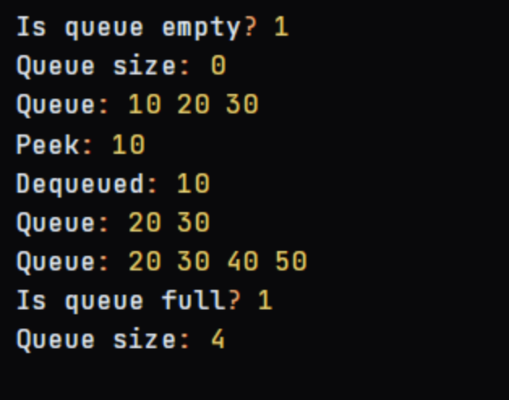
2.implement Queue (its operations) using Linked list(Pointers).
#include <stdio.h>
#include <stdlib.h>
typedef struct Node {
int data;
struct Node* next;
} Node;
typedef struct {
Node* front;
Node* rear;
int size;
} Queue;
void initQueue(Queue* q) {
q->front = NULL;
q->rear = NULL;
q->size = 0;
}
int isEmpty(Queue* q) {
return q->size == 0;
}
void enqueue(Queue* q, int element) {
Node* newNode = (Node*)malloc(sizeof(Node));
newNode->data = element;
newNode->next = NULL;
if (isEmpty(q)) {
q->front = newNode;
q->rear = newNode;
} else {
q->rear->next = newNode;
q->rear = newNode;
}
q->size++;
}
int dequeue(Queue* q) {
if (isEmpty(q)) {
printf("Queue is empty. Cannot dequeue.\n");
return -1;
}
int element = q->front->data;
Node* temp = q->front;
q->front = q->front->next;
if (q->front == NULL) {
q->rear = NULL;
}
free(temp);
q->size--;
return element;
}
int peek(Queue* q) {
if (isEmpty(q)) {
printf("Queue is empty. Cannot peek.\n");
return -1;
}
return q->front->data;
}
int size(Queue* q) {
return q->size;
}
void printQueue(Queue* q) {
Node* temp = q->front;
printf("Queue: ");
while (temp != NULL) {
printf("%d ", temp->data);
temp = temp->next;
}
printf("\n");
}
int main() {
Queue q;
initQueue(&q);
printf("Is queue empty? %d\n", isEmpty(&q));
printf("Queue size: %d\n", size(&q));
enqueue(&q, 10);
enqueue(&q, 20);
enqueue(&q, 30);
printQueue(&q);
printf("Peek: %d\n", peek(&q));
printf("Dequeued: %d\n", dequeue(&q));
printQueue(&q);
enqueue(&q, 40);
enqueue(&q, 50);
printQueue(&q);
printf("Queue size: %d\n", size(&q));
return 0;
}
OUTPUT:
